Lab 4. Testing the database operations

# Setup

1. Install MySQL Community 8.0.23 (Microsoft Visual C++ Redistributable for Visual Studio 2015, 2017 and 2019 might be needed to be installed before in windows)
2. Create a database got

*create database got;*

1. Go to **File -> New -> Spring Starter Project** to create a new Spring Project
2. Type the following information in the wizard:

**Service URL:** <https://start.spring.io>

**Name:** testDatabase

**Group:** mx.tec.lab

**Artifact**: testDatabase

**Description:** Database Operations Test Lab

**Package:** mx.tec.lab

1. Select Spring Boot Version 2.4.3 and click Finish
2. Open pom.xml file and verify you have the following dependencies

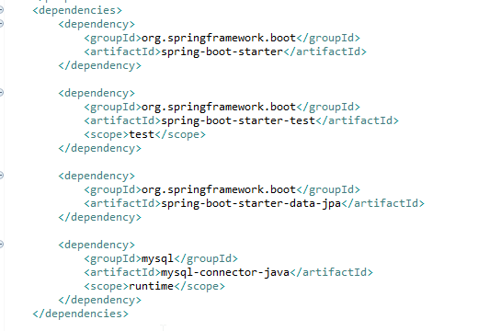

1. Verify that you have the **TestDatabaseApplication** class in src/main/java (Package Explorer)
2. Verify that you have the **TestDatabaseApplicationTests** class in src/test/java (Package Explorer)
3. Modify **application.properties** in src/main/resources. The MySQL password can be different depending on your setup

spring.datasource.url=jdbc:mysql://localhost:3306/got

spring.datasource.username=root

spring.datasource.password=admin

spring.datasource.driverClassName = com.mysql.cj.jdbc.Driver

spring.jpa.database = MYSQL

spring.jpa.show-sql = true

spring.jpa.generate-ddl = true

# Naming strategy

spring.jpa.hibernate.naming.physical-strategy=org.hibernate.boot.model.naming.PhysicalNamingStrategyStandardImpl

# Allows Hibernate to generate SQL optimized for a particular DBMS

spring.jpa.properties.hibernate.dialect=org.hibernate.dialect.MySQL5Dialect

1. Click on **Run As -> Maven clean**
2. Verify that clean was successful in the Console
3. Click on **Run As -> Maven install**
4. Verify that install was successful in the Console

# Exercise

1. Create Class **Dragon** in /src/main/java (in the correct package)

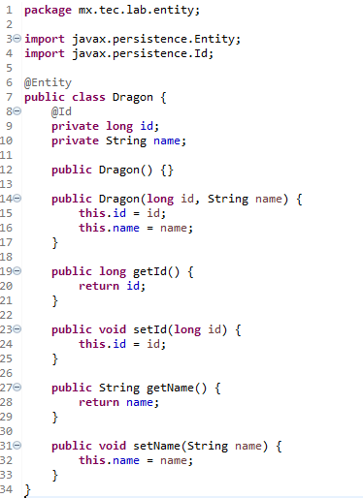

1. Create Interface **DragonRepository** in /src/main/java (in the correct package)

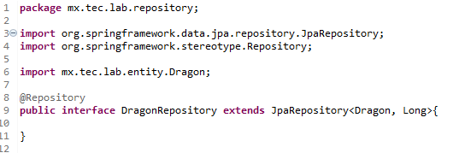

1. Delete Class **TestDatabaseApplicationTests**
2. Create Class **DragonRepositoryTest** in /src/test/java

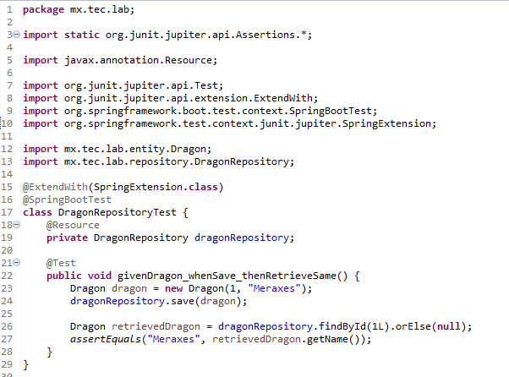

1. Run **Maven Test** and see the logs.
2. Verify in MySQL the **dragon** table content

SELECT * FROM got.dragon;

1. Delete the content of the dragon table and run the test again
2. Add a new dependency in your **pom.xml** file

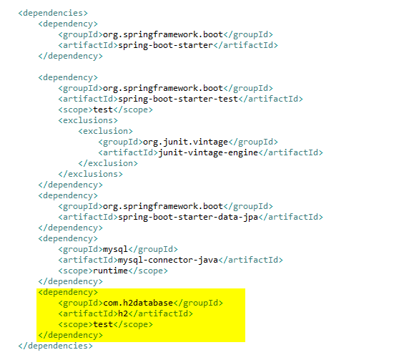

1. Add a new application.properties in src/**test**/resources

spring.datasource.driver-class-name=org.h2.Driver

spring.datasource.url=jdbc:h2:mem:testgot;DB_CLOSE_DELAY=-1

spring.datasource.username=sa

spring.datasource.password=sa

spring.jpa.show-sql = true

spring.jpa.generate-ddl = true

1. Delete the content of the dragon table in mysql and run **Maven Test** again and check the logs

# Challenge

1. What is the difference in step 5 and step 10?
2. Why we have created 2 **application.properties** files?
3. Create a new method to test a modification for an existing dragon (You will need to create the dragon before you try to modify it)
4. Create a new method to test the removal of an existing dragon (You will need to create the dragon before you try to remove it it)?
5. Why we are not mocking the Dragon Repository?